**General Provident Fund** (GPF)

It is a good saving instrument for government employees. The employee can contribute a portion of his/her salary regularly till the time he/she is employed.

1. First In Google address bar type “ [www.pdkv.ac.in](http://www.pdkv.ac.in)” on Dr. PDKV home page Click on Integrated University Management System (IUMS)

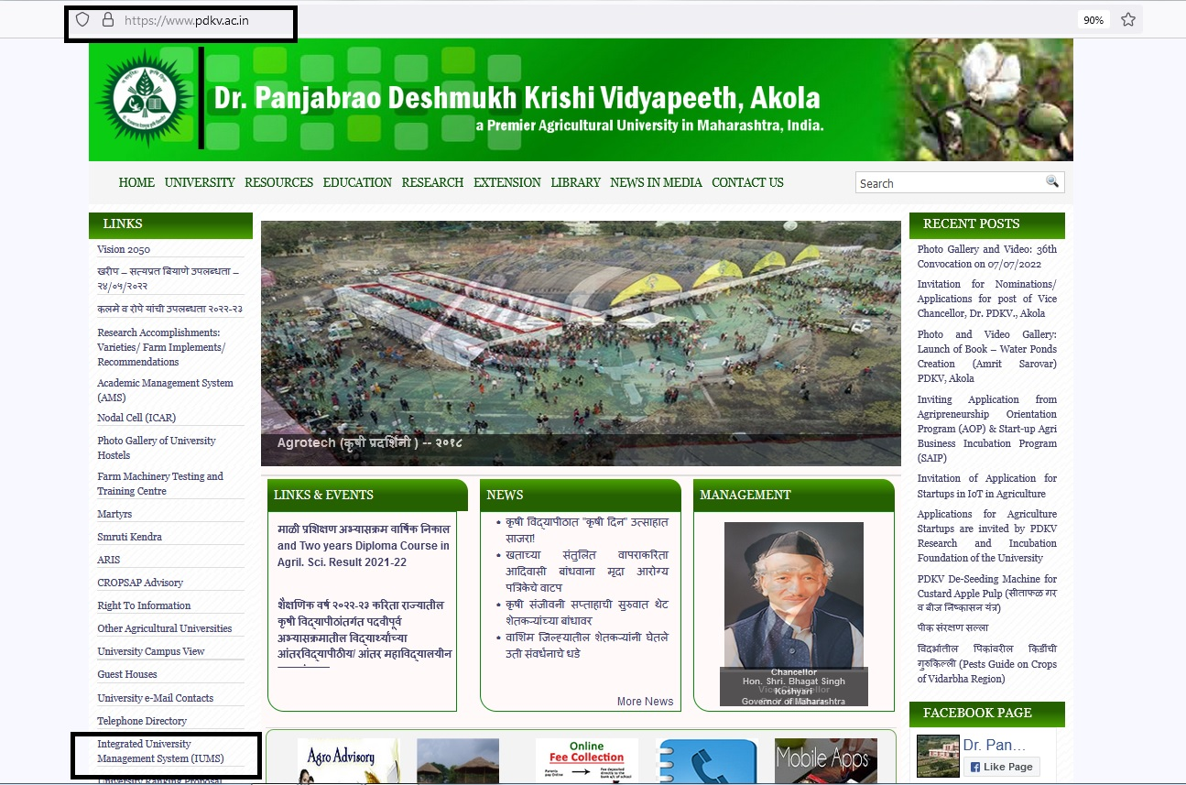

1. In this Login Page Type Your Login id And Password

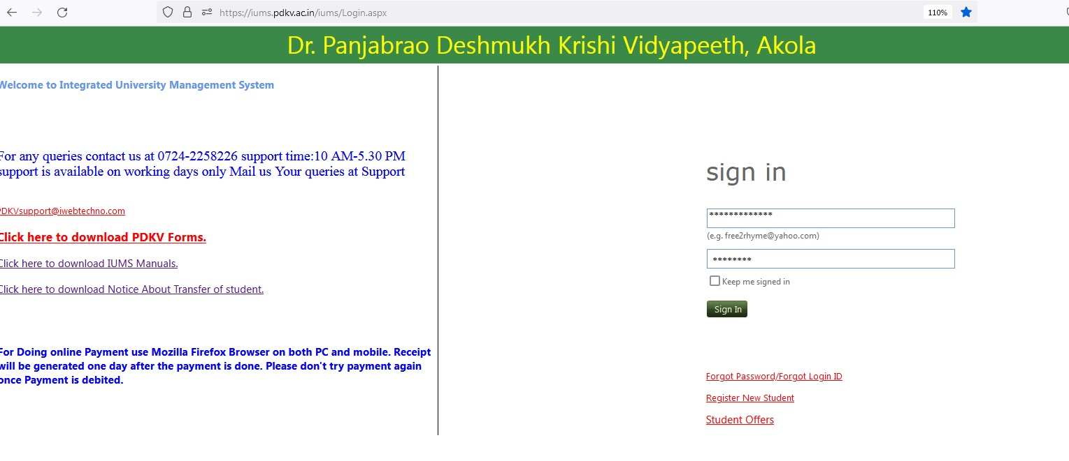

1. After Login You will get GPF Module inside

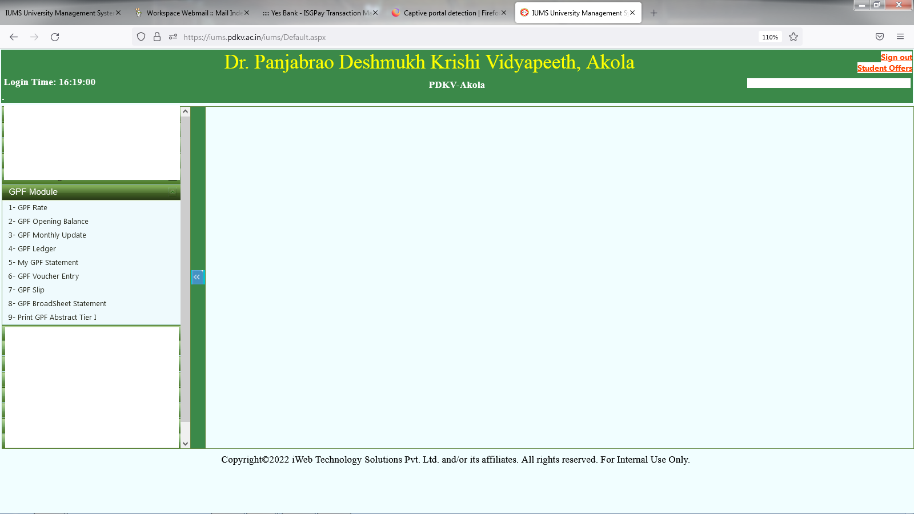

1)GPF Interest Rate : In this interest rate for the year is being added, so that according to interest rate the calculation of the employee is been done.

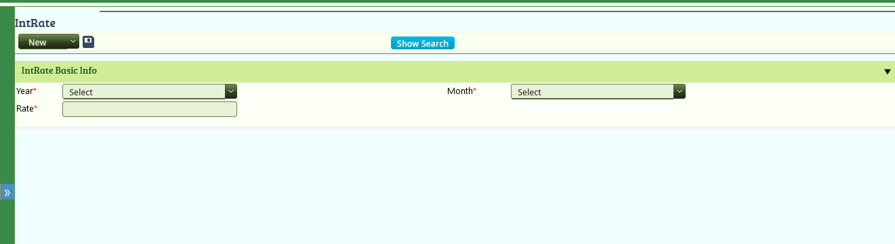

2) GPF Opening Balance : This is added once for the employee when it is first time joined in the university.

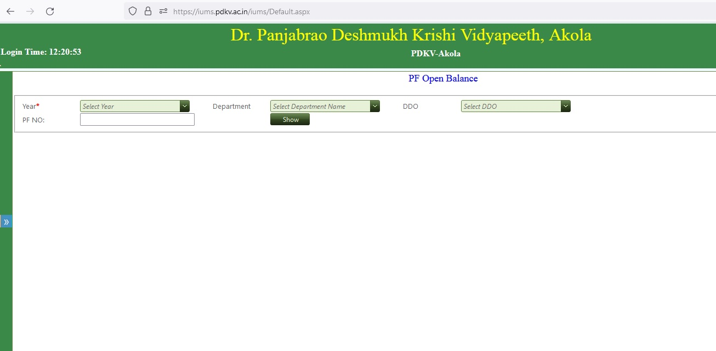

3) GPF Voucher Entry : Here Voucher is entered every month as per the deduction of the employees salary of department.

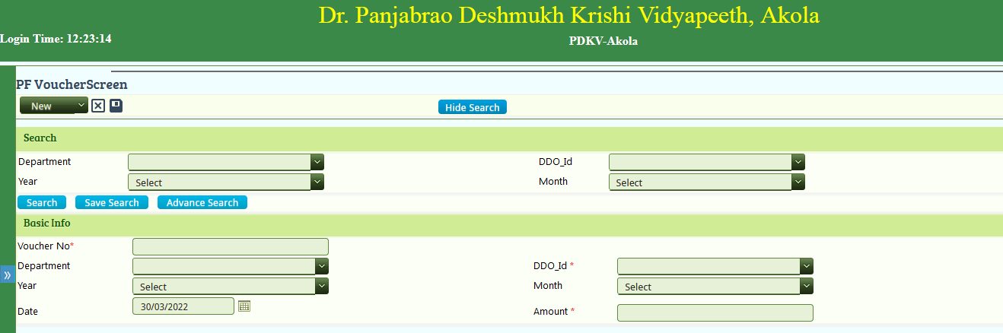

4)Monthly Update : In this screen all employees of the department monthly deduction is being added.

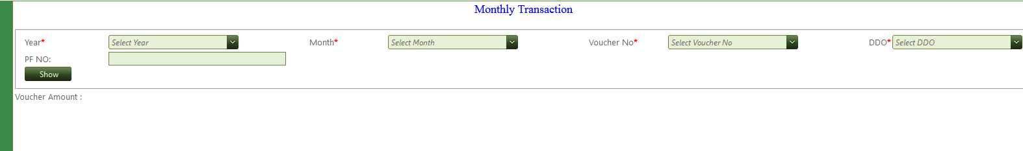

5) GPF Slip : In this Individual Employee GPF statement is being download in pdf report format as per year.

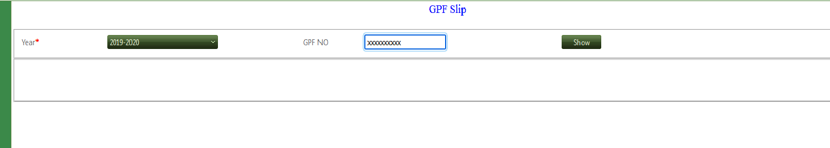

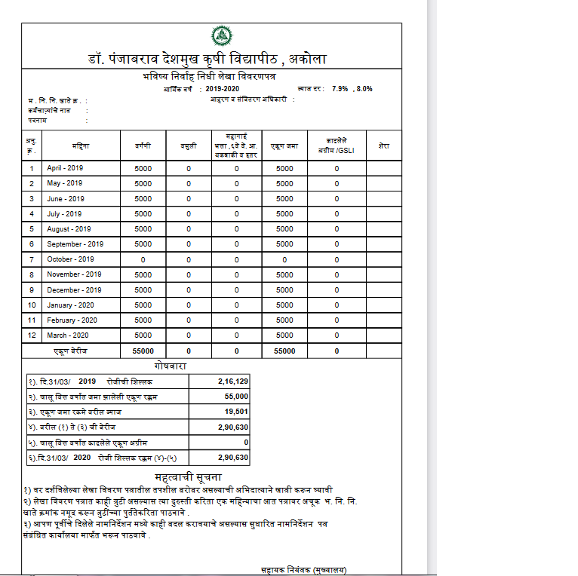

6) Broadsheet : In this all employees of department gpf calculation details is provided as per 12months.

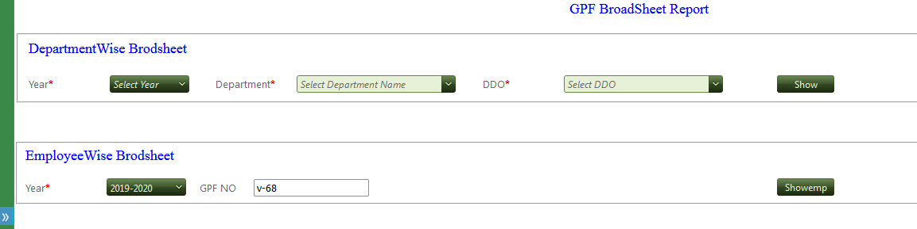

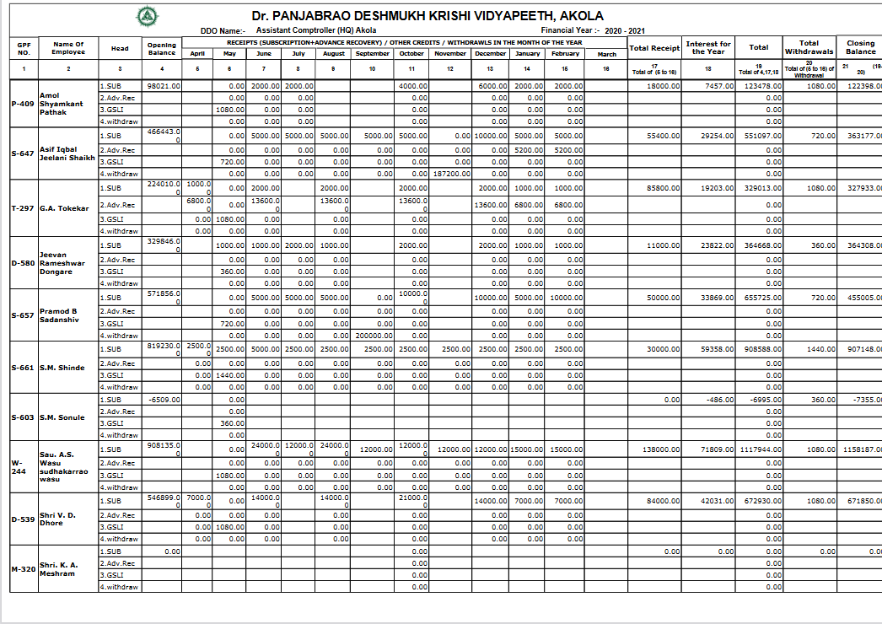

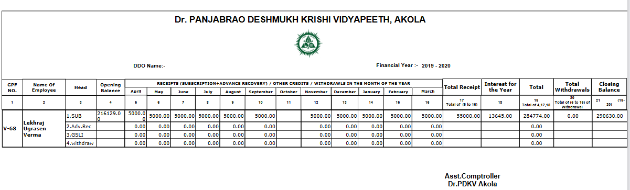

7) GPF Ledger : In this yearly data of individual employee is represented specifying TDA,DA,arreas.

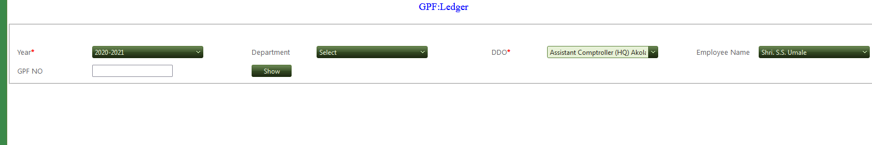

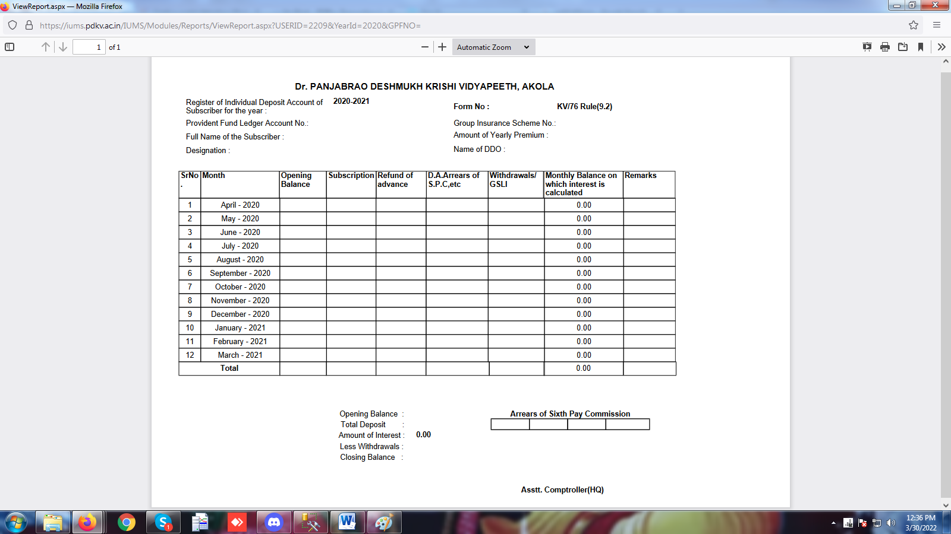

8) GPF Abstract Tier I : In this abstract of the Individual employee is given according to starting to ending year.

