**Defined Contribution Pension** (DCPS)

Government of India had introduced a new **Defined Contribution Pension Scheme**(DCPS) with effect from 01.01. 2004 vide Government of India, Ministry of Finance, Department of Economic Affairs Notification, dated 22-12-2003.

1. First In Google address bar type “ [www.pdkv.ac.in](http://www.pdkv.ac.in)” on Dr. PDKV home page Click on Integrated University Management System (IUMS)

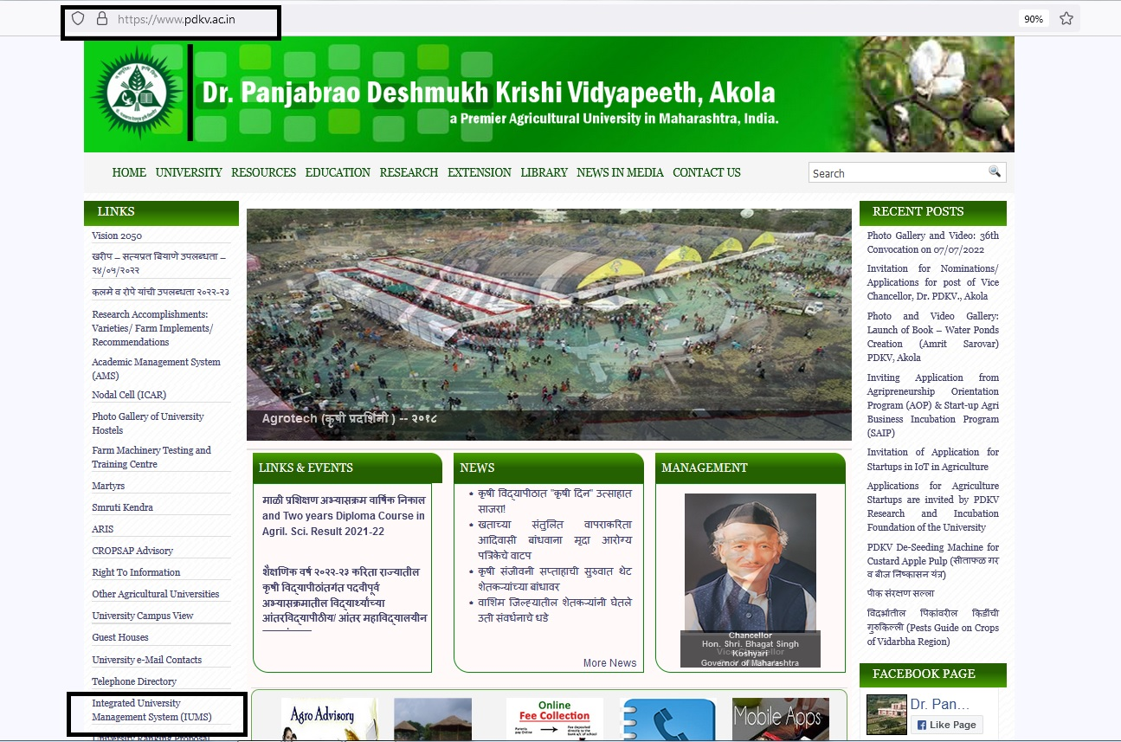

1. In this Login Page Type Your Login id And Password

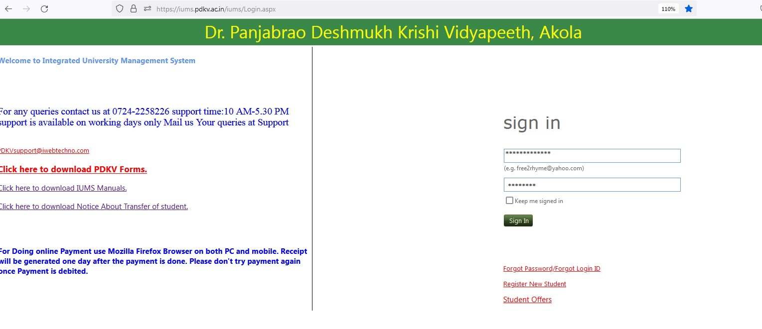

1. After Login You will get DCPS Module inside

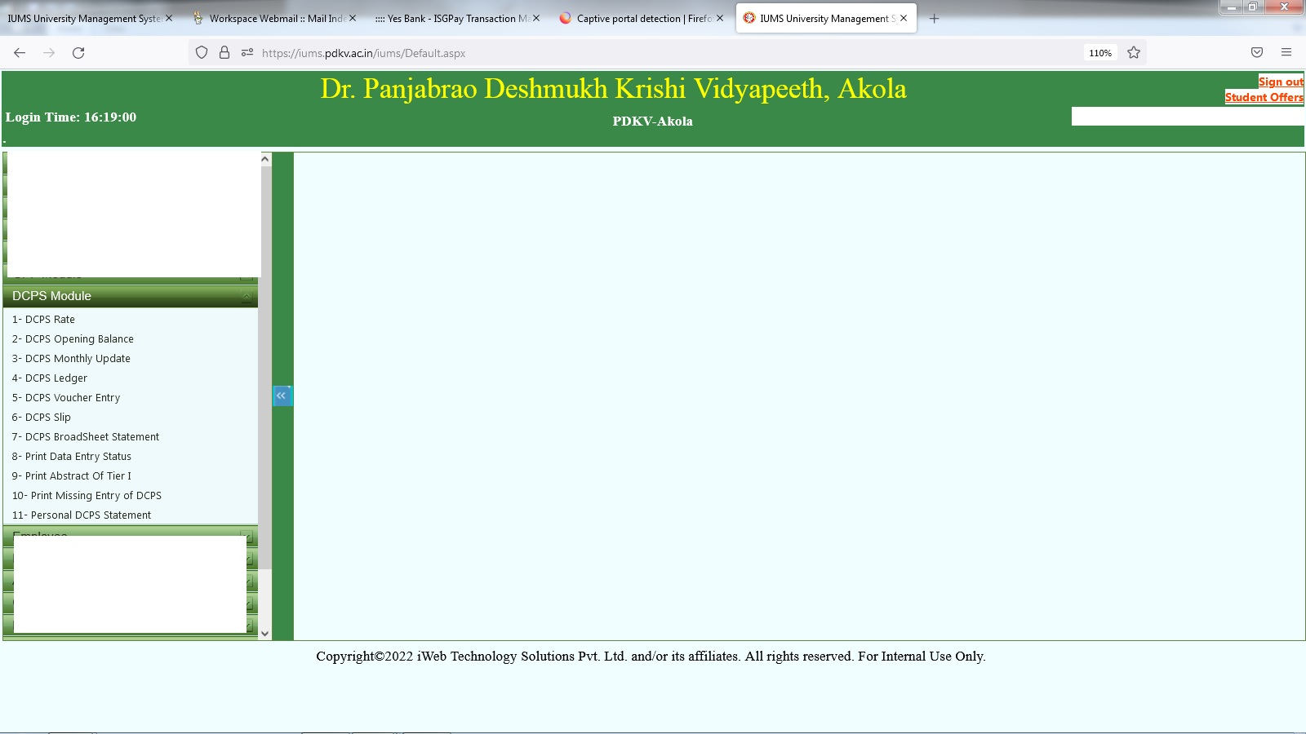

1)DCPS Interest Rate : In this interest rate for the year is being added, so that according to interest rate the calculation of the employee is been done.

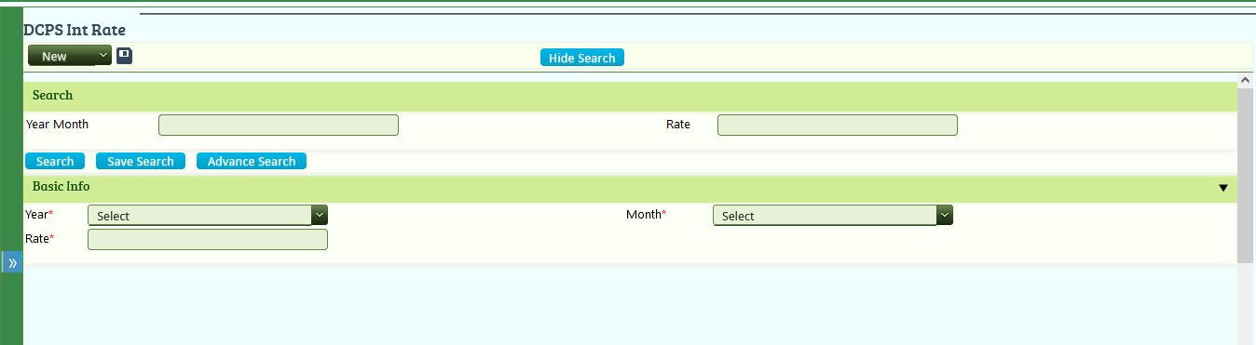

2) DCPS Opening Balance : This is added once for the employee when it is first time joined in the university.

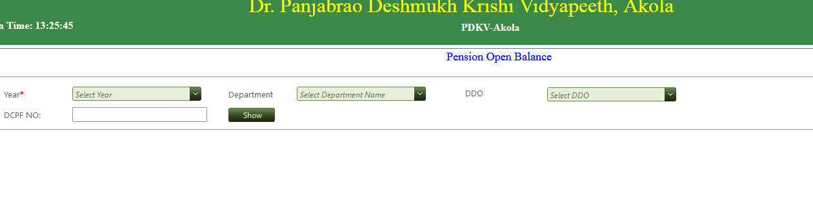

3) DCPS Voucher Entry : Here Voucher is entered every month as per the deduction of the employees salary of department.

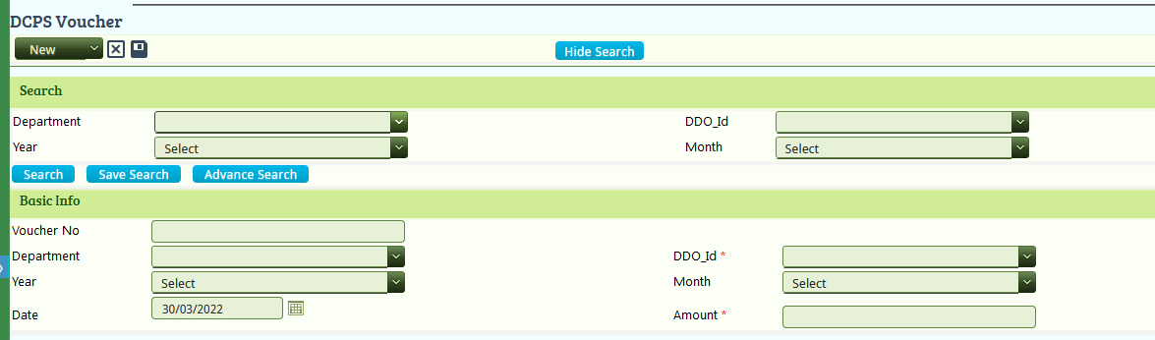

4) Monthly Update : In this screen all employees of the department monthly deduction is being added.

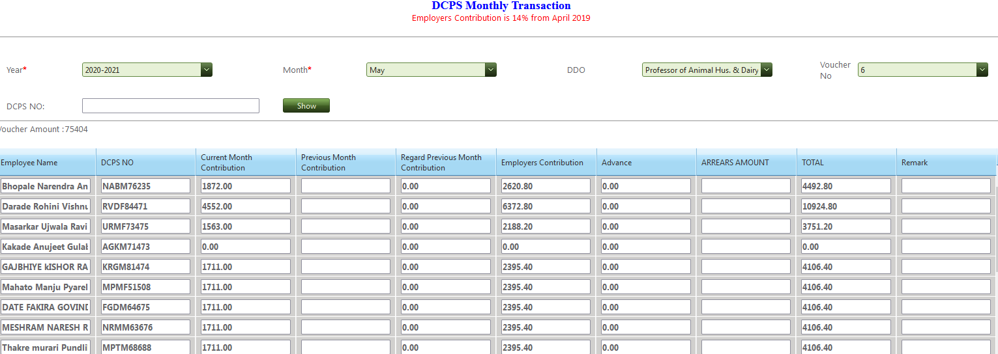

5)DCPS Slip : In this Individual Employee DCPS statement is being download in pdf report format as per year.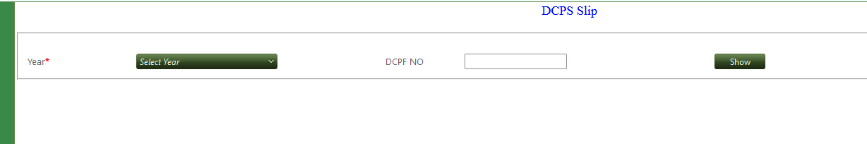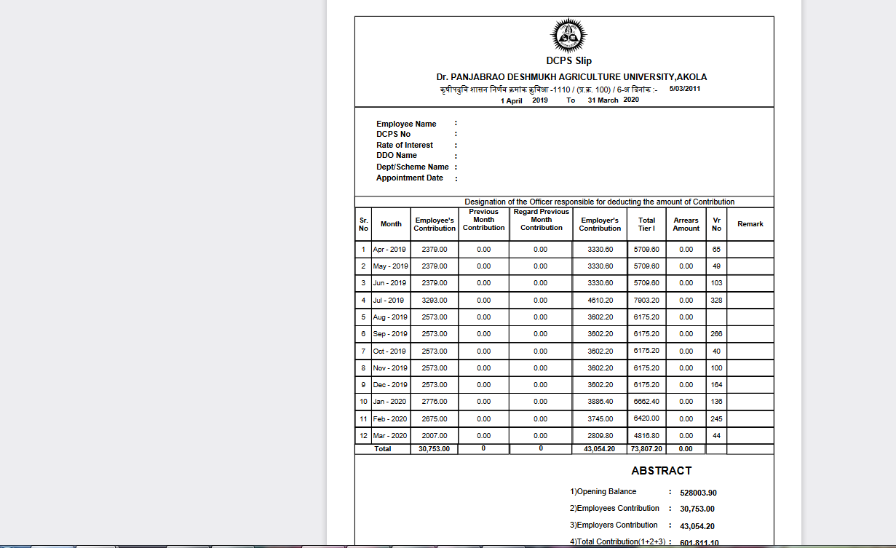

6) Broadsheet : In this all employees of department DCPS calculation details is provided as per 12months.

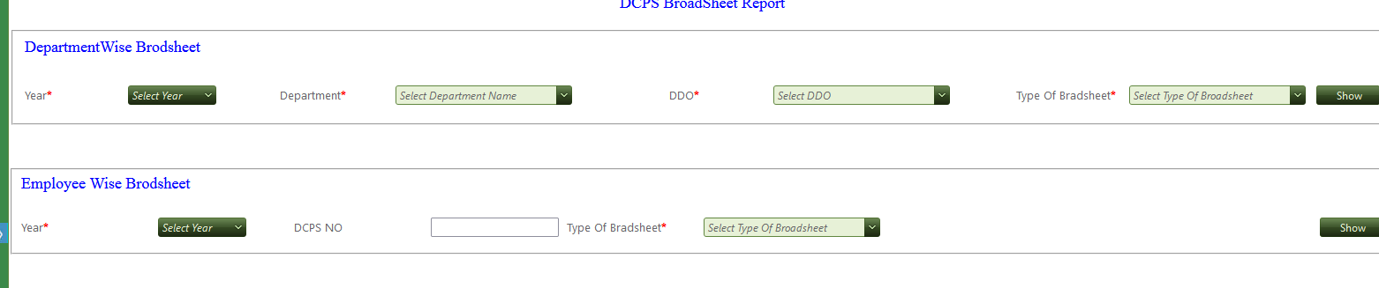

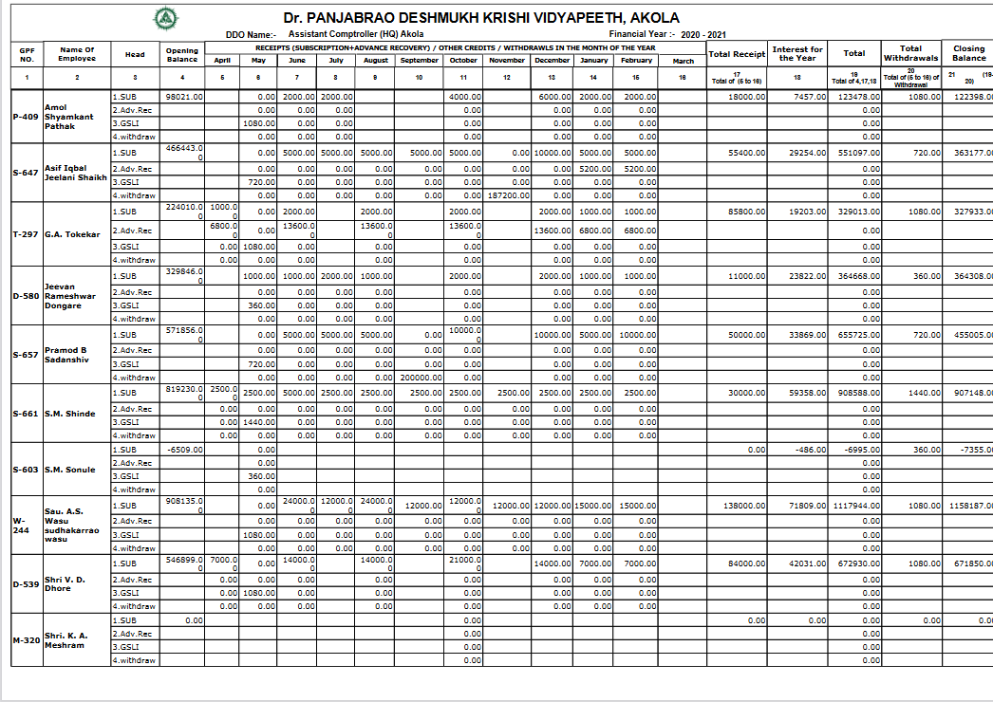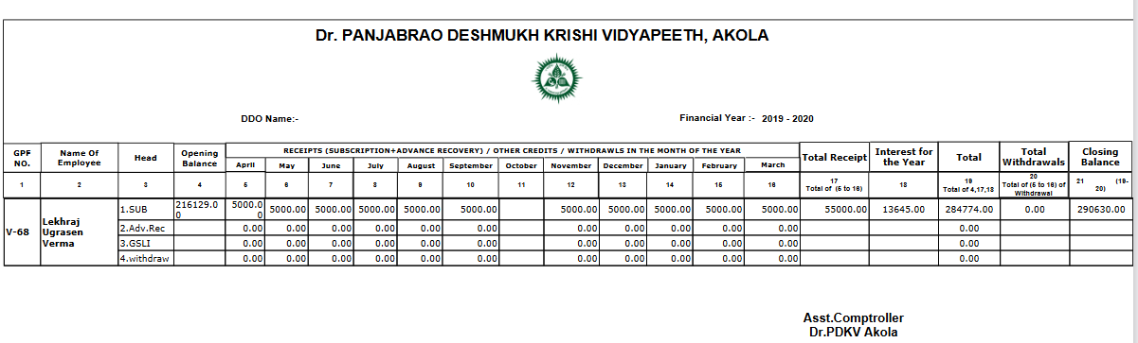

7) DCPS Abstract Tier I : In this abstract of the Individual employee is given according to starting to ending year containing employee and employeer contribution,Rate of interest .

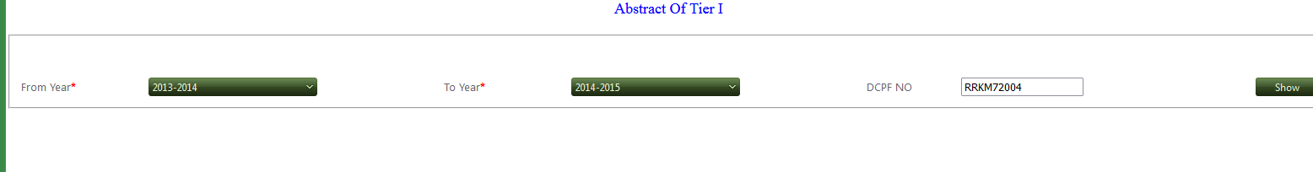

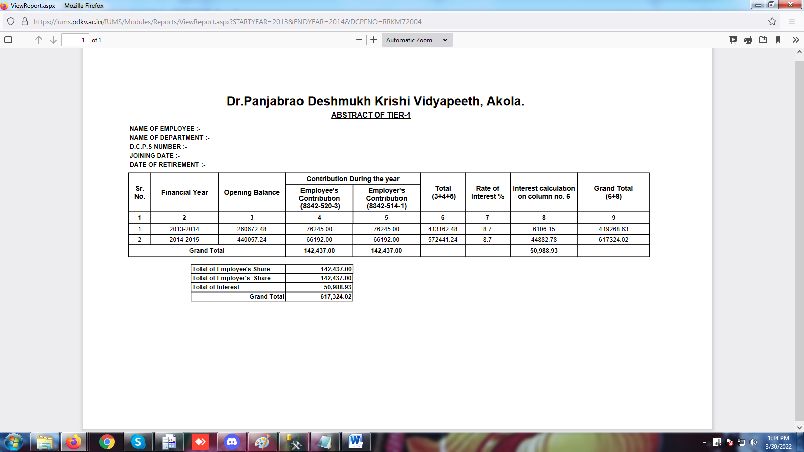

8) DCPS Missing Entry :In this all employee whose entry are missing is showing according to year and month of individual department

