Process To Make Online Payment
Note:
While Making Payment Use Mozilla FireFox Browser Version 47.0

1)Go To The Address Bar in Browser and Enter url

“ https://www.pdkv.ac.in ” and then Click Enter
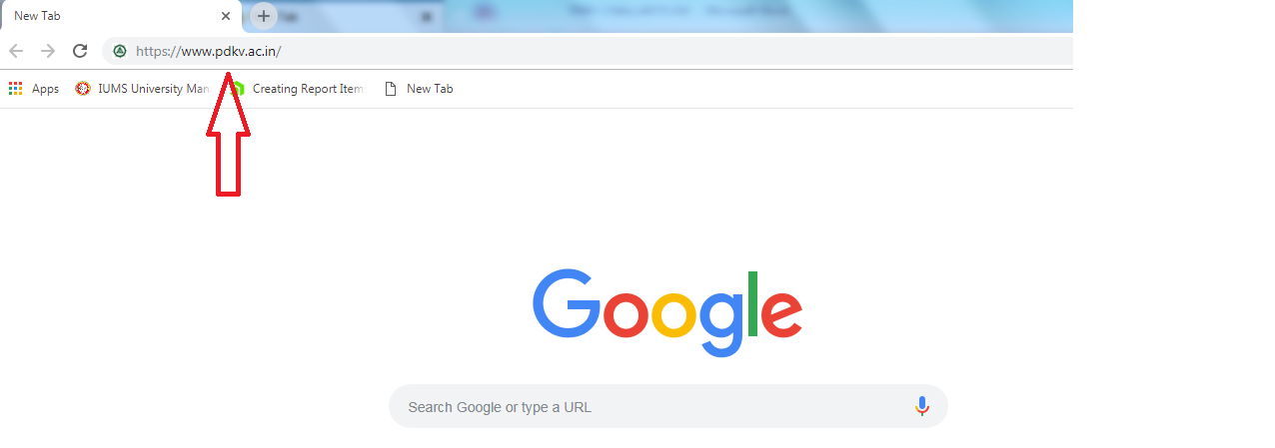

2)Now Click on the Link Below “Integrated University Management System (IUMS)” in the Link menu on the left side.
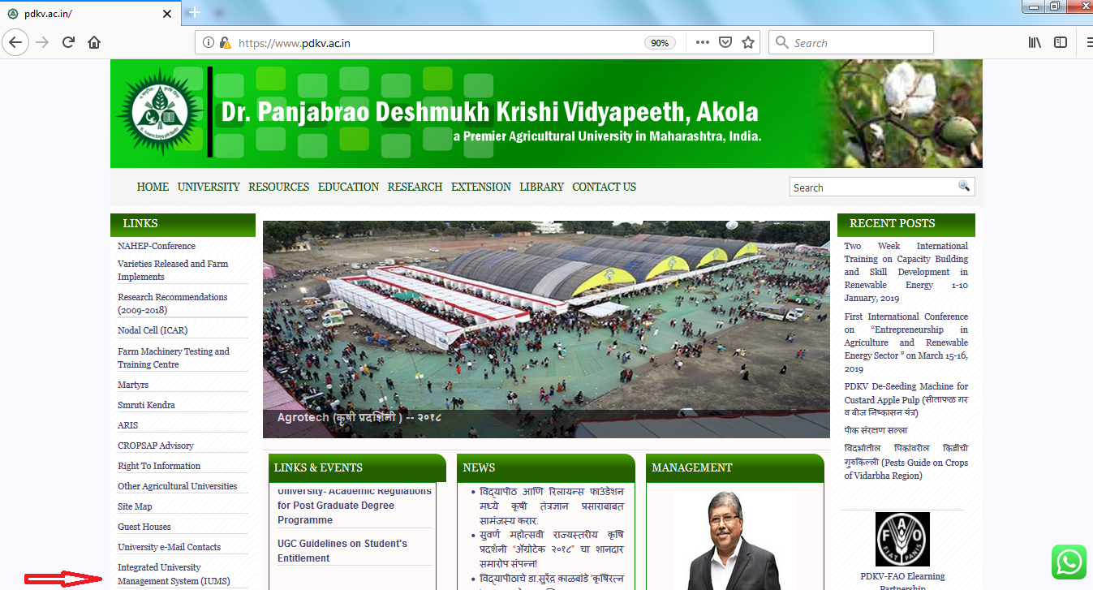

3)Now On Login Page Enter Your Login_id and Password of Iums and Sign In
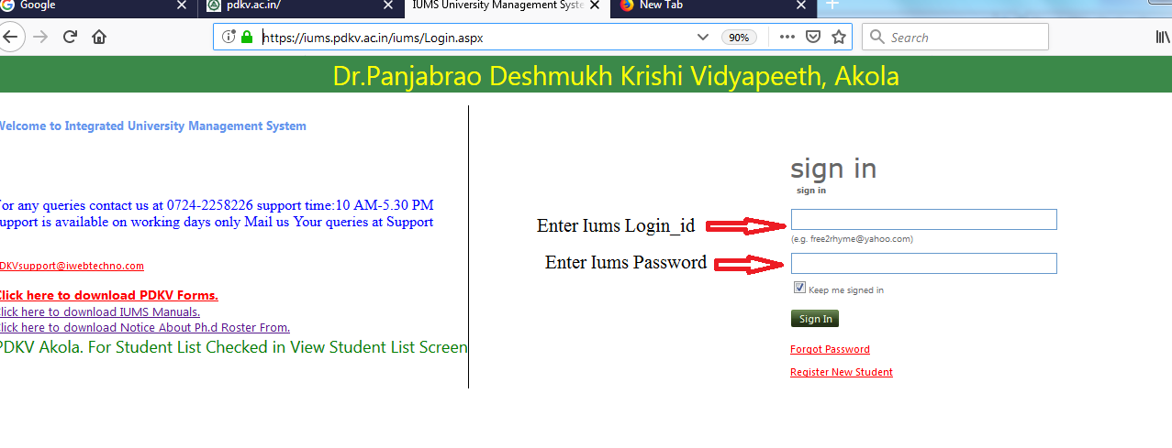
4)After Login Go To Admission Process Tab Click and In that Click Online Misc Fee Payment
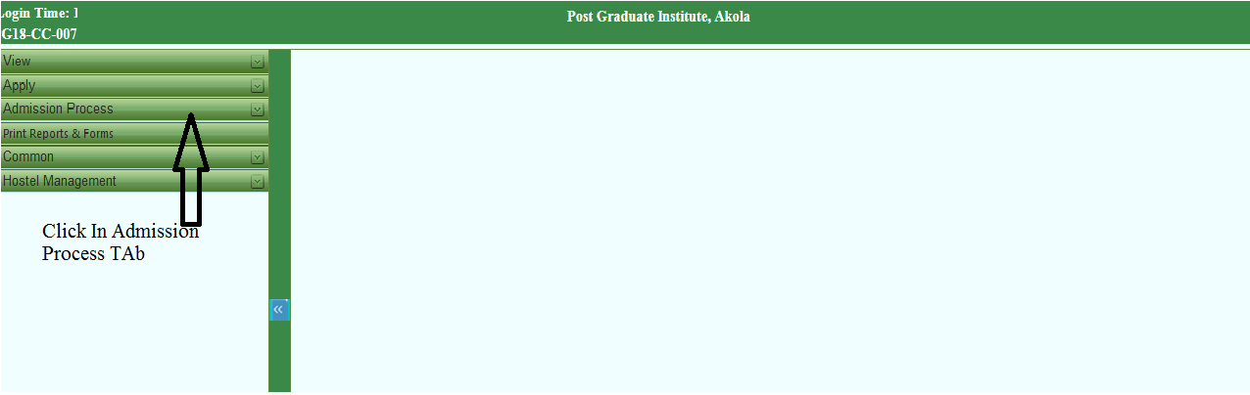

5)Miscellaneous Fee Receipt
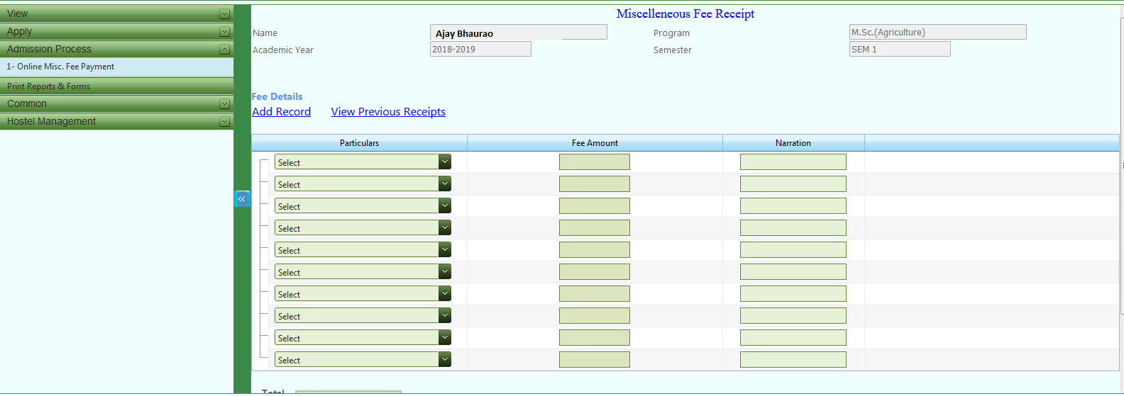

6)Add Particular From the dropdown
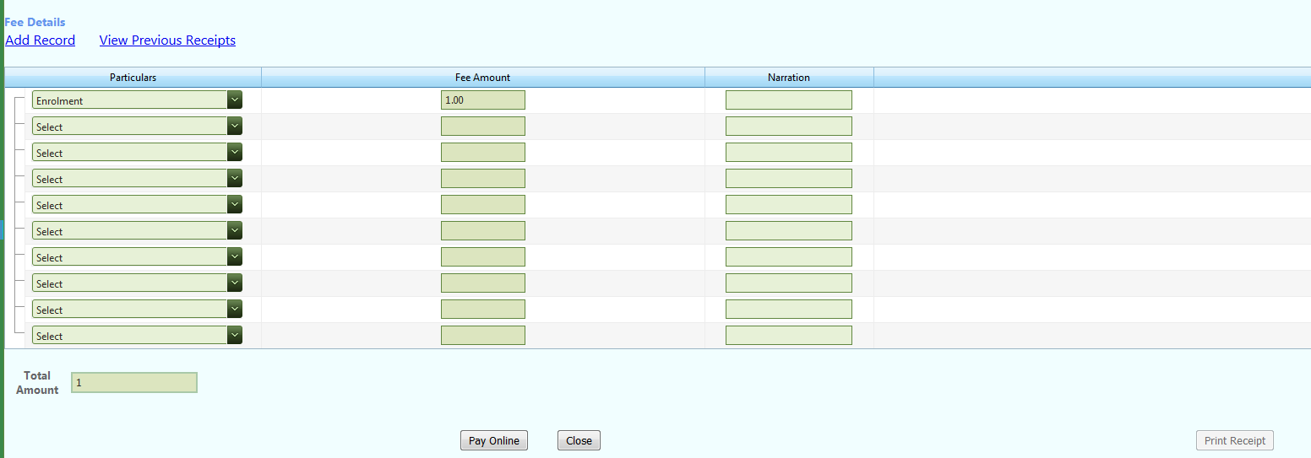
7)After Clicking on Pay Online Button
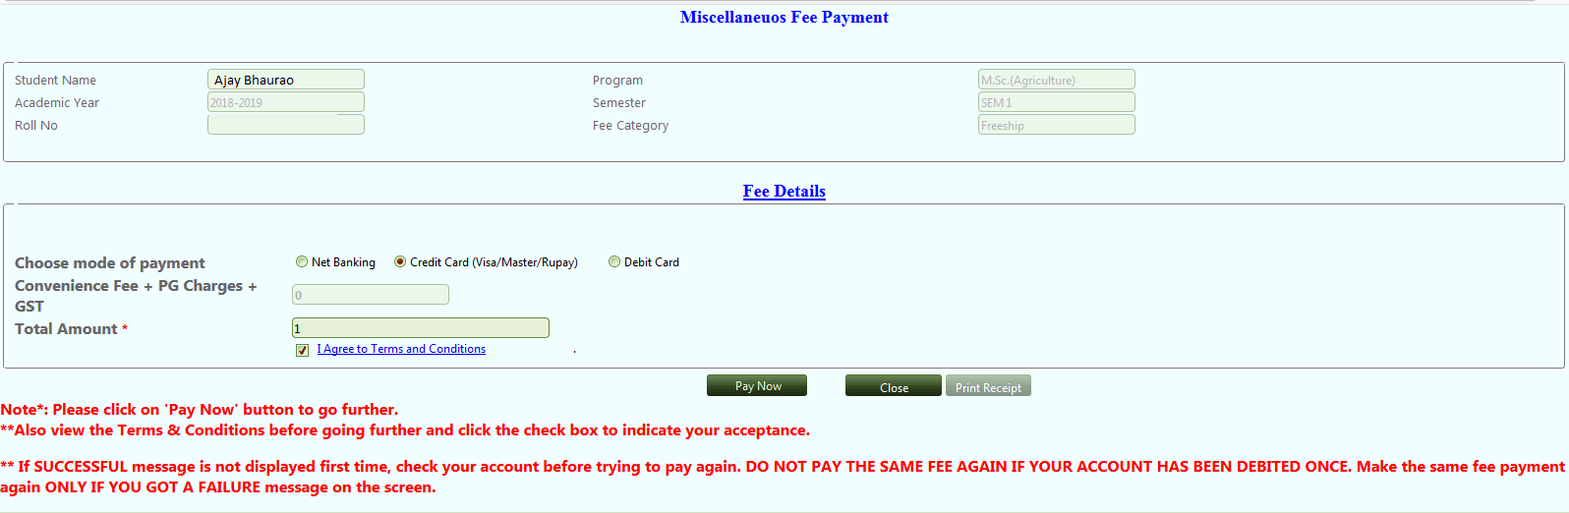

8)Click on I agree Terms And Conditions And Pay Now Button
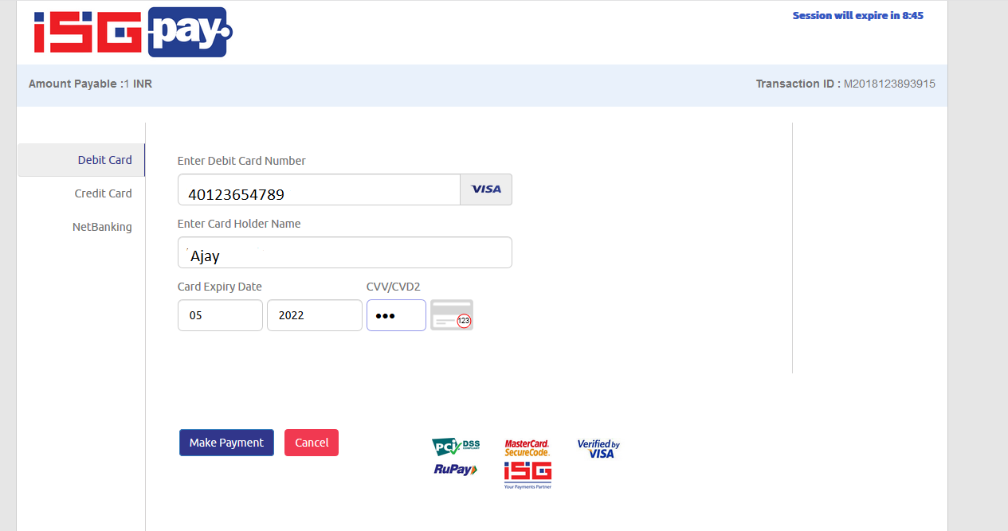

9)OTP Screen Generated Enter OTP sent On your Mobile number
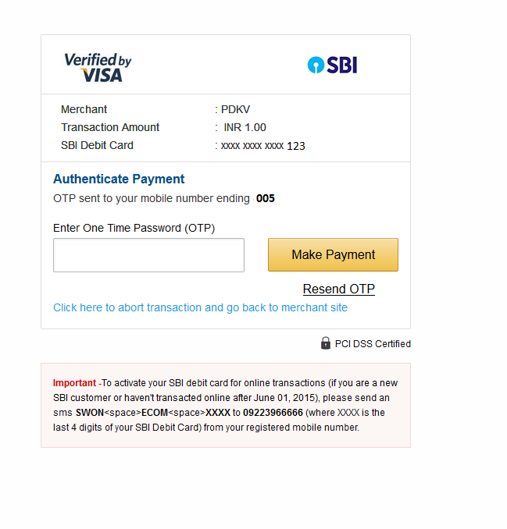

10)Bank Reciept Generated Then Click on Close Button.
Note :
Receipt Will Be Generated After 24 Hours Once The Payment Is Made.
If Transaction Fails And Amount Is Debited Then Amount Will Be Refunded Within 3 Days.

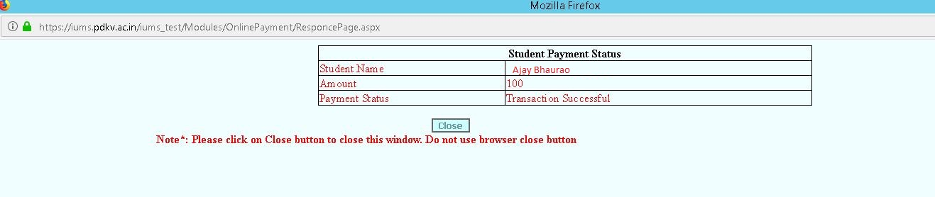
11)We will be Redirecting to Iums page Now Click on Print Receipt Button
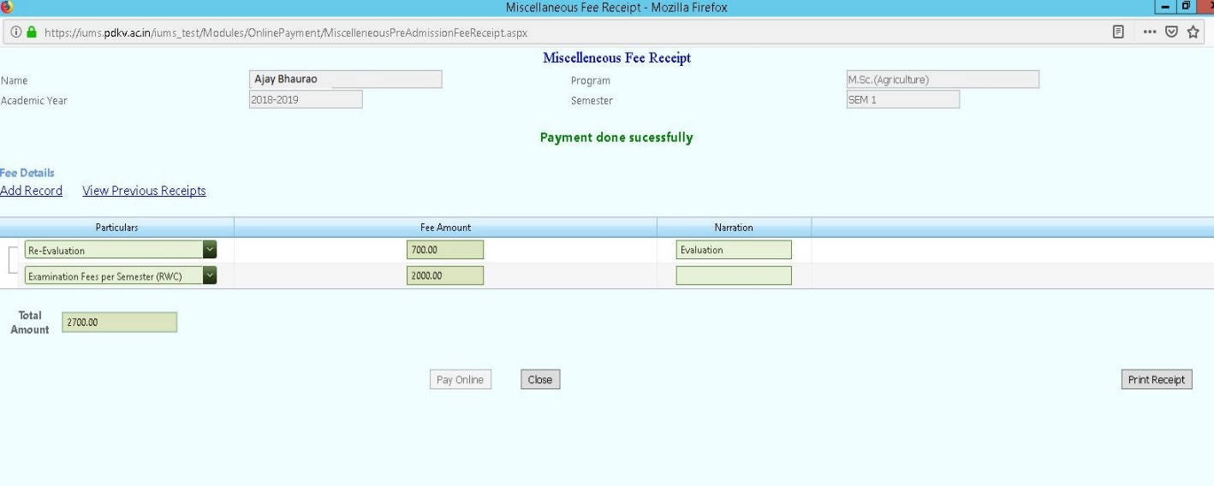

12)Reciept Of Student challan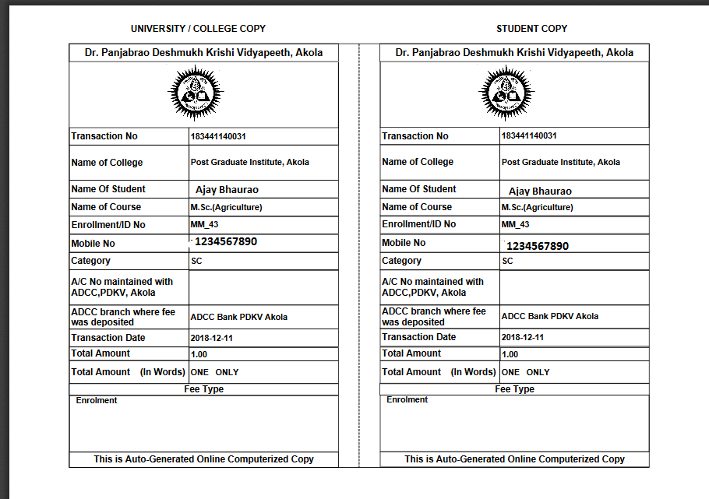
13)Now Click On View Previous Record To View Previous Reciept History
14)Previous Reciept Link and After Clicking View Reciept Link 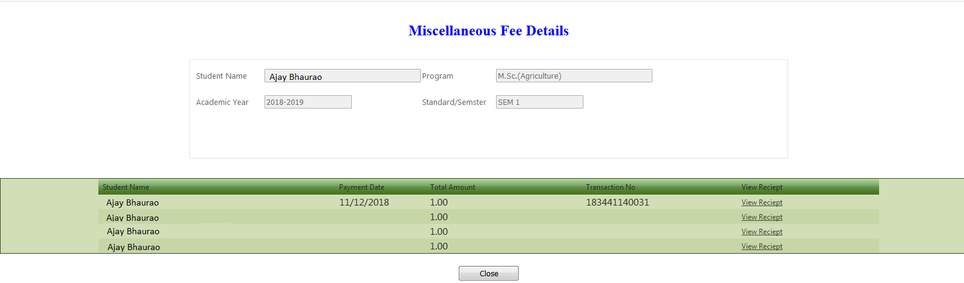

15)Previous Reciept of student

